<<Customer Logo>> 

[CUSTOMER NAME – SYSTEM NAME]
Requirement Specifications
For <<App Name>>

Version: 0.7

Singapore, July 2021
Approval Page
The endorsement on this document by authorized [Customer Name] representative indicates [Customer Name] and FPT’s agreement on the “[Project Name] Requirement Specifications” document.

Prepared by : | (FPT)  Business Analyst | Signature: | ____________________
 |  | Date: | ____ /____ / ____
Reviewed by : | (FPT)  Project Manager | Signature: | ____________________
 |  | Date: | ____ /____ / ____
Supported by: | (Customer Name) | Signature: | ____________________
 |  | Date: | ____ /____ / ____
Approved by : | (Customer Name) | Signature: | ____________________
 |  | Date: | ____ /____ / ____

Revision History
Date | Version | Author | Change Description
DD/MM/YYYY | 0.5 | Author | First Creation
 | 0.7 |  | For internal review
 | 0.8 |  | For the first release to customer
 | 0.9.x |  | For updating version while reviewing with customer
 | 1.0 |  | For official sign-off

Table of Contents

1. Introduction 6
1.1 Purpose 6
1.2 Overview 6
1.3 Intended Audience and Reading Suggestions 6
1.4 Abbreviations 6
1.5 References 7
2. High Level Requirements 8
2.1 Object Relationship Diagram 8
2.2 Workflow 13
2.2.1 Support Service Management Process 14
2.2.2 Solution Handling Process 16
2.3 State Transition 17
2.3.1 Support Service Management Process State Transition 18
2.3.2 Solution Handling Process State Transition 19
2.4 Use Case Diagram 19
2.4.1 Case and Solution Management Use Case Diagram 20
2.4.2 Manage Use Case Diagram 22
2.4.3 Other Use Case Diagram 24
2.5 Permission Matrix 25
2.6 Site Map 31
2.6.1 Site Map for Customer Portal 31
2.6.2 Site Map for Internal Portal 32
3. Use Case Specifications 35
3.1 Customer Portal 35
3.1.1 UC 1: Submit Case 35
3.2 Internal Portal 37
3.2.1 Workflow Use Case 37
3.2.2 Manage Use Case 40
3.2.3 Other Use Case 46
3.2.4 Scheduled Job 47
3.3 Common Use Cases 48
3.3.1 CMUC 1: View list of Items 48
3.3.2 CMUC 2: Create Item 49
3.3.3 CMUC 3: Read Item 50
3.3.4 CMUC 4: Update Item 51
3.3.5 CMUC 5: Delete Item 52
3.4 Common Business Rules 53
4. Mockups Screen 55
4.1 Customer Portal 55
4.1.1 Case List Screen 55
4.1.2 Create Case Screen 57
4.2 Internal Portal 60
4.2.1 Case Detail Screen 60
5. Non-Functional Requirements 63
5.1 Performance Requirements (optional) 63
5.2 Safety Requirements (optional) 64
5.3 Security Requirements (optional) 64
5.4 Software Quality Attributes (optional) 64
6. Other Requirements 66
6.1 Common field controls 66
6.2 Common Messages Configuration 67
6.3 View Columns Display 67
6.4 Pagination 68
6.5 Search Component 68
6.6 Bulk Action 69
7. Integration 70
8. Data Migration 70
8.1 Migration Scope 70
8.2 Data Mapping 70
9. Appendices 71
9.1 Messages List 71
9.1.1 Error Message 71
9.1.2 Inline Error Message 71
9.1.3 Confirmation Dialog 71
9.1.4 Success Dialog 72
9.2 Email Templates 73
9.2.1 ET 1: Sending email to Customer after submitting Case 73
9.2.2 ET 2: Sending email to Customer after Solution is submitted 74
9.2.3 ET 3: Sending email to Support Engineer after Solution is accepted. 74
9.2.4 ET 4: Sending Email to System Admin of auto-closing Cases. 75

Introduction

Purpose
This System Requirements Specification is a formal statement of the system’s functional and non-functional requirements. The document lays out capabilities that the system must provide and required constraints by which it must abide. It serves as a basis for an agreement between customers and contractors or suppliers on how the system should function.
Specifically, this document will:
- Define the scope of business objectives, functions, and structure.
- Identify business processes facilitated by the solution.
- Develop a common understanding of functional requirements for all parties involved.
- Establish a basis for defining acceptance tests.

Overview
<Overview of this project>

Intended Audience and Reading Suggestions
This document is intended for:
- Development team: Responsible for developing detailed design, implement and perform unit test, integration test and system test for the migrated application
- Data Migration team: Responsible for creating data migration scripts, and perform data migration for the application.
- Documentation Team: Responsible for writing User Guide for the application if required.
- UAT team: Responsible for conducting user acceptance test sessions with end users.

Abbreviations
<Template only: List out all Acronym used in this documents and sort them alphabetically.>

Acronym | Reference
SRS | System Requirement Specification
UC | Use Case
BR | Business Rules
CBR | Common Business Rules
ET | Email Template
N/A | Not Applicable or Not Available
MSG | Message
[Field] | Convention for mentioning a field
<<Field>> | Convention for value of this field, specifically use in the context of Email Template
“Text Value” | Convention for mentioning a value
<Value> | Convention for mentioning special value, i.e. <Today>, <Current User>
TBU | To be Updated

References
<Template only: List any other documents or Web addresses to which this SRS refers. These may include user interface style guides, contracts, standards, system requirements specifications, use case documents, or a vision and scope document. Provide enough information so that the reader could access a copy of each reference, including title, author, version number, date, and source or location.
List any version information relating to external Tools, Plugins or Platforms that the system uses or is built upon.
If not, note N/A>

Title | Reference | Description
Title of Document / Website | Link to the Document or Website | Description of the purpose or information provided by the Document, Website.
Title of Tools, Plugins or Platforms | Link to the Tools, Plugins or Platforms Website. | Version information of the Tools, Plugins or Platforms that the systems uses or is built upon.

High Level Requirements
This section describes the general overview of the system functions or business processes which are depicted in different diagrams. It shows the types of users, their granted permissions to perform specific system functions and the sequence required to complete a business workflow (if any). As the section name implies, it is high-level which means not detailed enough. For detailed requirement specification, please see Use Case Specifications section below.

Object Relationship Diagram
This section shows the static relationship between actor and object as well as between object and object in the system and their interactions with external systems. An object could be described as an instance of a particular entity in the system.
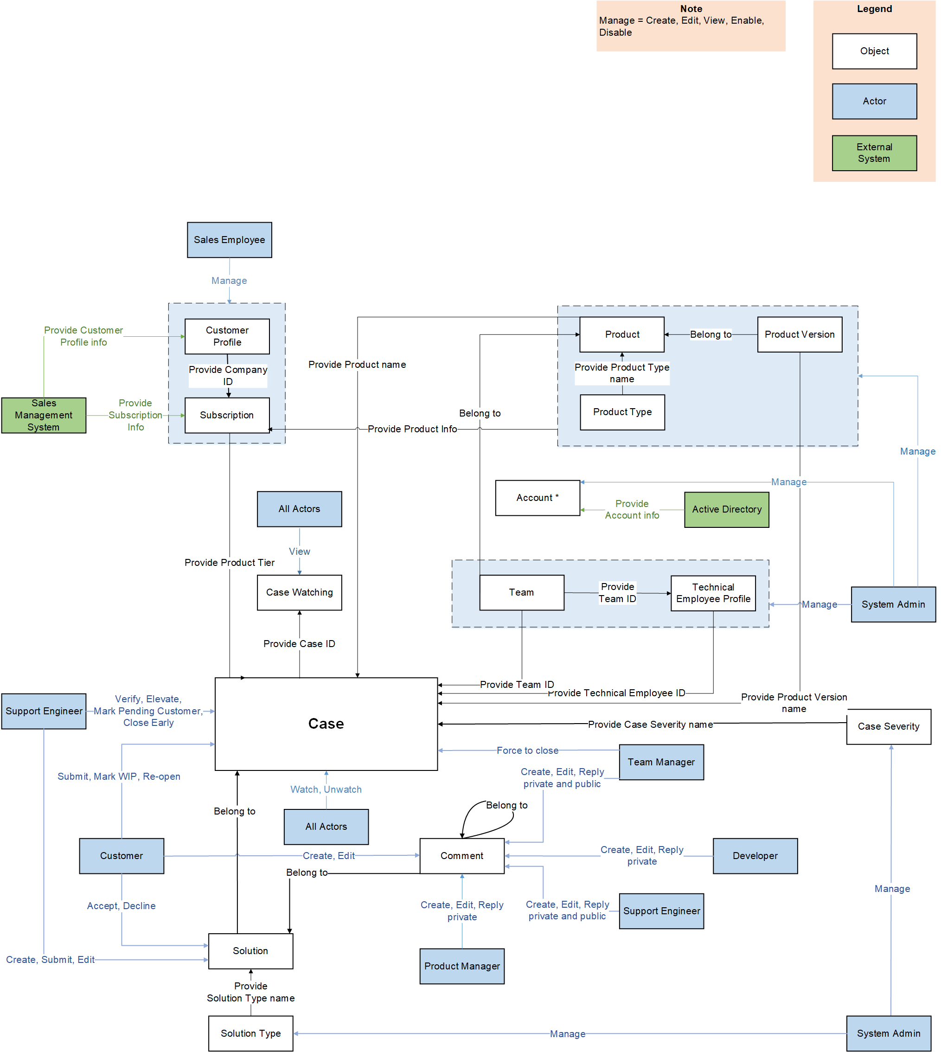
Figure 1: Object Relationship Diagram
Object Description:
# | Object | Description
Object
 | Case | This data object contains information of all the Cases in the system. Each Case is submitted by Customer, processed by Support Engineer L1, Support Engineer L2, Support Engineer L3 with the support of Developers and Team Managers. This data object contains some fields such as Customer name, Product Tier, Case Severity, Assignee, etc.
 | Case Severity | This data object contains information of Case Severity. Each Case Severity is managed by System Admin. This data object contains some fields such as SLA, etc.
 | Case Watching | This data object contains information of account that follows a Case. Each Case Watching is auto-generated by system. This data object contains some fields such as Account, Case, etc.
 | Comment | This data object contains information of all Comments. Each Comment can be created and edited by all the Accounts. This data object contains some fields such as Description, Reply to (which identifies the comment is replied to Case, Solution or another Comment), etc.
 | Solution | This data object contains information of all the Solutions. Each Solution is submitted by Support Engineer and approved or rejected by Customer. This data object contains some fields such as Description, Solution Status, Solution Type, etc.
 | Solution Type | This data object contains information of all the Solution Types. Each Solution Type is managed by System Admin. This data object contains some fields such as Solution Type name.
 | Customer Profile | This data object contains information of all the Customer. This information is get from Sales Management System. This data object contains some fields such Name, Country, etc. Each Company has only one “Customer Profile”, which means each Company has one User Account for all their employees to log into the system and submit Cases. Whoever logs into Company’s account can view all Cases created by that Companies.
 | Subscription | This data object contains information of all Subscription. This information is get from Sales Management System. This data object contains some fields such as Customer name, Product, Product Version, Product Tier, etc.
 | Product | This data object contains information of all the Products. Each Product is managed by System Admin. This data object contains some fields such as Product name, Product type, etc.
 | Product Version | This data object contains information of all the Product Versions. Each Product Version is managed by System Admin. This data object contains some fields such as Product name, Product Version Name, Released Date, etc.
 | Product Type | This data object contains information of all the Product Types. Each Product Type is managed by System Admin. This data object contains some fields such as Product Type Name, etc.
 | Team | This data object contains information of all the Teams. Each Team is in charge of a Product and managed by System Admin. This data object contains some fields such as Team name. Team Manager, Product name, etc.
 | Technical Engineer Profile | This data object contains information of all the Technical Engineer Support Engineer belonged to a Team, which includes Product Manager, Developer, Team Manager and Support Engineer. Each profile is managed by System Admin. This data object contains some fields such as Level, Team name, etc.
 | Account | - This data object contains information of all the Accounts. Account of Customer is managed by System Admin and Account of Employee is get from Active Directory.  - This object provides Account info for below-mentioned objects:  - Case  - Comment  - Solution  - Case Watching  - Technical Engineer Profile  - Customer Profile
Actor
 | Customer | - This is Customer who is in charge of submitting Case and providing more detailed materials.  - This actor will have the permission to access site with Customer's view, to Create, Edit, View their Case in the system.  - System can recognize user as "Customer" when User is using an account with <<User Role>> = " Customer".
 | Support Engineer L1 | - This is who will be mainly in charge of resolving Case.  - This actor will have the permission to access site with internal employee’s view, to Verify, Elevate, Close Case, Change its Status and Manage Solution.  - System can recognize user as "Support Engineer L1" when User is using an account with <<User Role>> = "Support Engineer L1".
 | Support Engineer L2 | - This is who will be mainly in charge of resolving Case.  - This actor will have the permission to access site with internal. employee’s view, to Verify, Elevate, Close Case, Change its Status and Manage Solution.  - System can recognize user as "Support Engineer L2" when User is using an account with <<User Role>> = "Support Engineer L2".
 | Support Engineer L3 | - This is who will be mainly in charge of resolving Case.  - This actor will have the permission to access site with internal employee’s view, to Verify, Elevate, Close Case, Change its Status and Manage Solution.  - System can recognize user as "Support Engineer L3" when User is using an account with <<User Role>> = "Support Engineer L3".
 | Developer | - This is Developer who has responsibility to support the Support Engineer.  - This actor will have the permission to View Case and manipulate Comment.  - System can recognize user as "Developer" when User is using an account with <<User Role>> = " Developer".
 | Team Manager | - This is Team Manager who has responsibility to review and control the progress of solving Case submitted by the Support Engineer.  - This actor will have the permission to View Case and Force Close Case if there is some particular problem about Customer.  - System can recognize user as "Team Manager" when User is using an account with <<User Role>> = "Team Manager ".
 | System Admin | - This is System Admin who has responsibility to manage some of the configuration in the system.  - This actor will have the permission to Create, Edit, Update Solution Type, Case Severity, Product Type, Site.  - System can recognize user as "System Admin" when User is using an account with <<User Role>> = “System Admin”.
 | Product Manager | - This is Product Manager who has the responsibility to manage all the Product's information; support and comment on Cases.  - This actor will have the permission to Create, Edit, Update Product and its Version.  - System can recognize user as "Product Manager" when User is using an account with <<User Role>> = “Product Manager”.
External System
 | Sales Management System | This external system provides data of Customer Profile and Subscription.
 | Active Directory | This external system provides data of account of Employees.

Workflow
This section shows the flow of tasks or steps taken by each actor of the system in order to complete a business process. The actor’s actions are shown in each business process stage of the system along with the conditions under which it can move to the next stage or revert to the previous.

Support Service Management Process
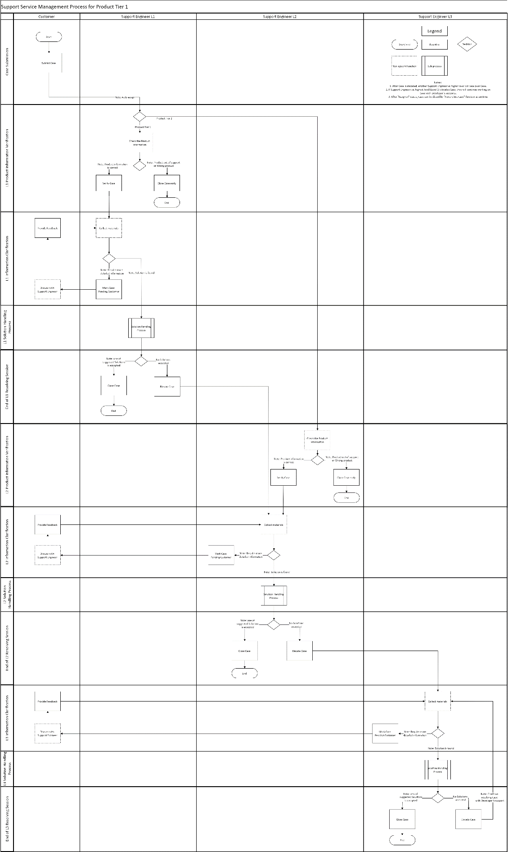
Figure 2: Support Service Management Process
Please refer to file to view the workflow diagram of Support Service Management Process more clearly.
Workflow explanation:
- After Customer submits Case, Case is assigned to Support Engineer based on Team and Product Tier. Each Team is in charge of a Product. There are 2 Product Tiers (1 and 2):
  - Case with Product Tier 1 is assigned to Support Engineer level 1 of the Team being in charge of Product in the Case.
  - Case with Product Tier 2 is assigned to Support Engineer level 2 of the Team being in charge of Product in the Case.
- Support Engineer proceeds to:
  - Close Case early if Product is out of support or any information of Product is wrong.
  - Verify Case if Product information is valid.
- After collecting materials for verified Case, Support Engineer:
  - Moves on to Solution Handling Process if Solution is found.
  - Mark Case Pending Customer if need more detailed information.
    - Customer now discusses further details with Support Engineer and Provide Feedback.
    - Support Engineer goes back to collecting materials after discussion with Customer.

Solution Handling Process
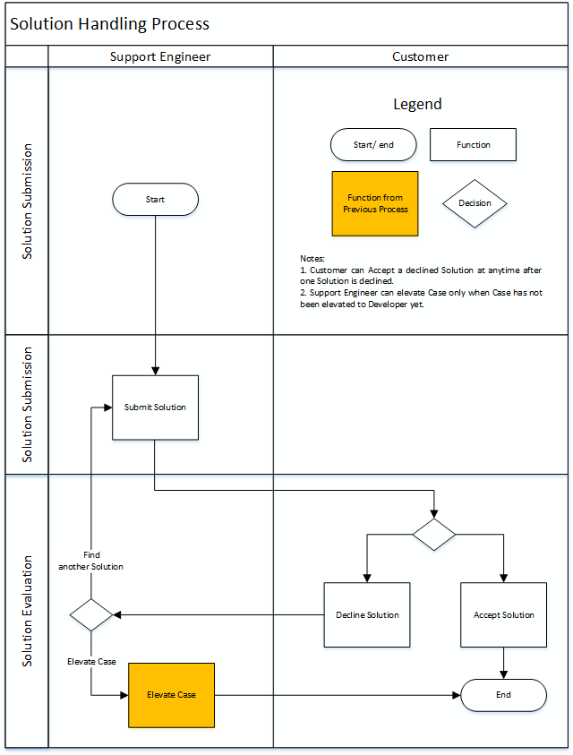
Figure 3: Solution Handling Process
Workflow Explanation:
- Support Engineer submits Solution for corresponding Case.
- Customer proceeds to Accept or Decline Solution.
  - If Solution is accepted by Customer, Support Engineer will close Case.
  - If Solution is declined by Customer, Support Engineer will:
    - Submit Solution if another Solution is found.
    - Elevate Case to Support Engineer of higher level if no Solutions are found.
      - If level of current Support Engineer is 1, Case is elevated to Support Engineer level 2 of the same team. Support Engineer level 2 goes back to collecting materials.
      - If level of current Support Engineer is 2, Case is elevated to Support Engineer level 3 of the same team. Support Engineer level 3 goes back to collecting materials.
      - If level of current Support Engineer is 3, Support Engineer asks for support from Developer of the Product and goes back to collecting materials.
  - Customer can accept solution which has been declined before that.

State Transition
This represents the behavior of the system in response to user’s actions by changing state of data objects. The circle shows the state. The line that connects one state to another shows the action required for that state change to happen. These actions are usually triggered by an actor.

Support Service Management Process State Transition
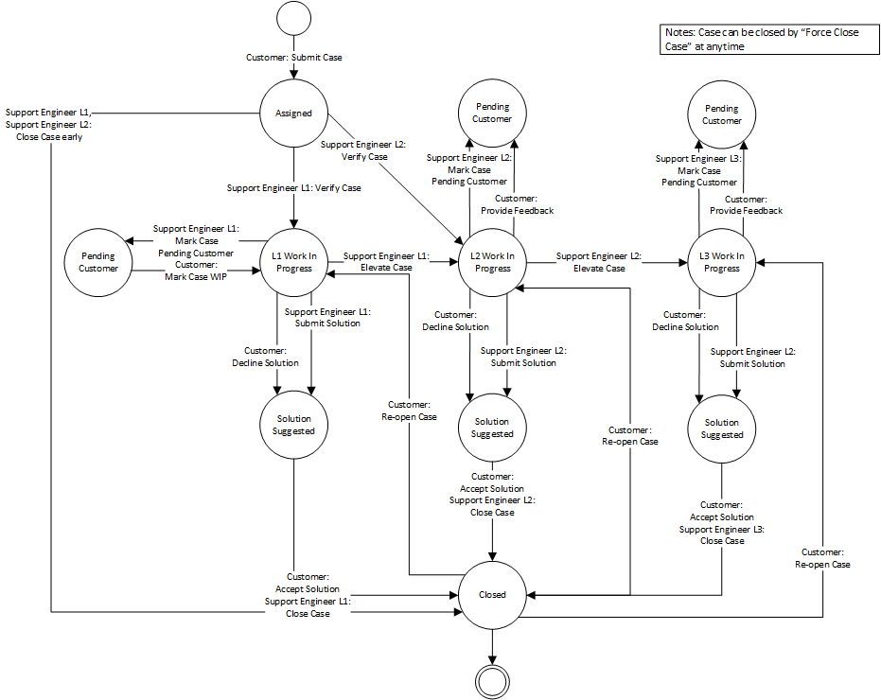
Figure 4: Support Service Management Process State Transition

Solution Handling Process State Transition
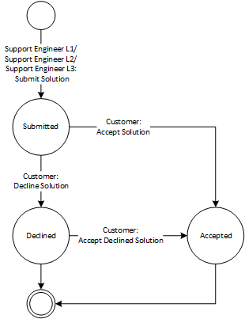
Figure 5: Solution Handling Process State Transition

Use Case Diagram
The use case diagram here shows the specific goal and objective or how the actor interacts with the system. The ellipse in the system boundary represents the system use case/functions while the stickman represents the actor of the system. The line connecting the actor and the use case shows that the actor can perform that function in the system to achieve a goal.
(Use UML standard for UC diagram)

Case and Solution Management Use Case Diagram
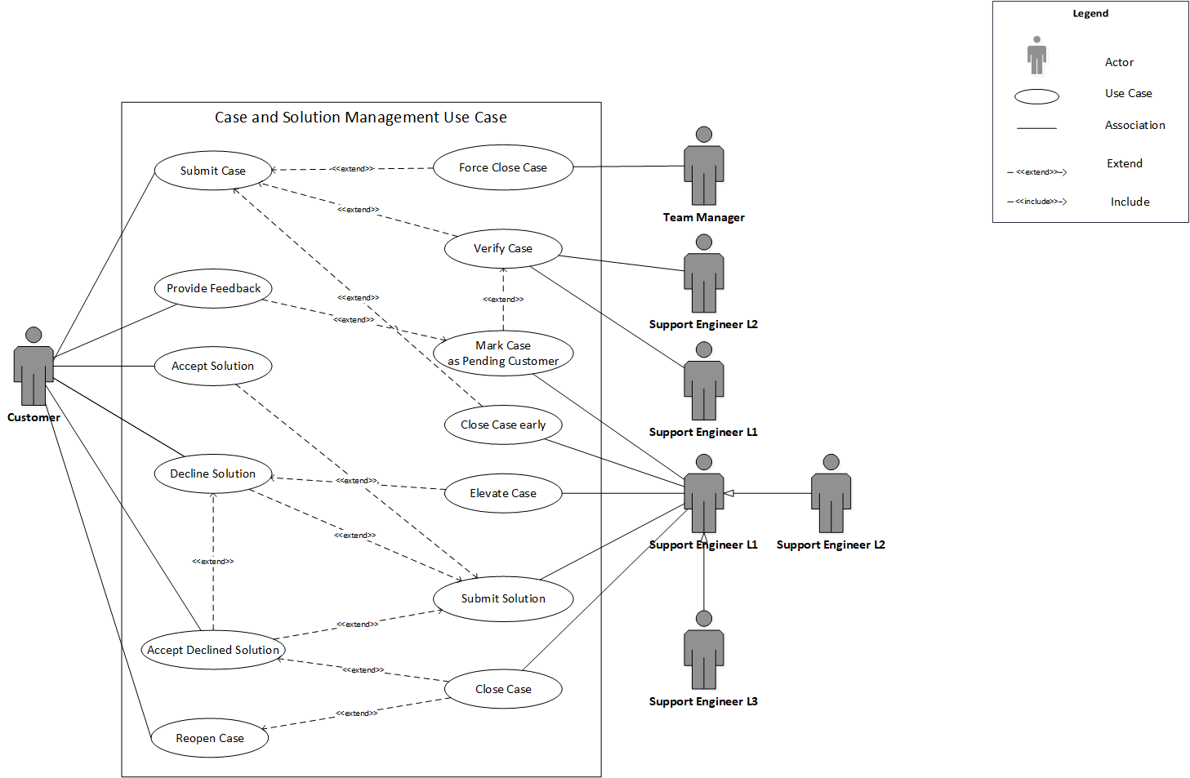
Figure 6: Case and Solution Management Use Case Diagram
# | UC Name | Description
 | Submit Case | This function allows Customer to submit a new Case.
 | Verify Case | This function allows Support Engineer L1, Support Engineer L2 to verify information about Product in Case.
 | Elevate Case | This function allows Support Engineer L1, Support Engineer L2, Support Engineer L3 to assign Case to another Support Engineer or Developer.
 | Mark Case Pending | This function allows Support Engineer to change Case Status and notify Customer about their needs.
 | Provide Feedback | This function allows Customer to change Case Status back to "Work In Progress" and notify Support Engineer L1, Support Engineer L2, Support Engineer L3 about their responses.
 | Close Case | This function allows Support Engineer L1, Support Engineer L2, Support Engineer L3 to close Case.
 | Close Case early | This function allows Support Engineer L1, Support Engineer L2, Support Engineer L3 to close Case when Case is "Assigned" after submitting Solutions which do not need Customer's Acceptance to close Case.
 | Force Close Case | This function allows Team Manager to close Case without Customer's acceptance if Customer takes too much time to respond (7 days after last communication) or does not respond or deliberately blocks the process of resolving Case.
 | Reopen Case | This function allows Customer to reopen closed Case.
 | Submit Solution | This function allows Support Engineer L1, Support Engineer L2, Support Engineer L3 to submit Solution.
 | Accept Solution | This function allows Customer to accept Solution.
 | Accept Declined Solution | This function allows Customer to accept Solution which has been declined by himself before.
 | Decline Solution | This function allows Customer to decline Solution.

Manage Use Case Diagram
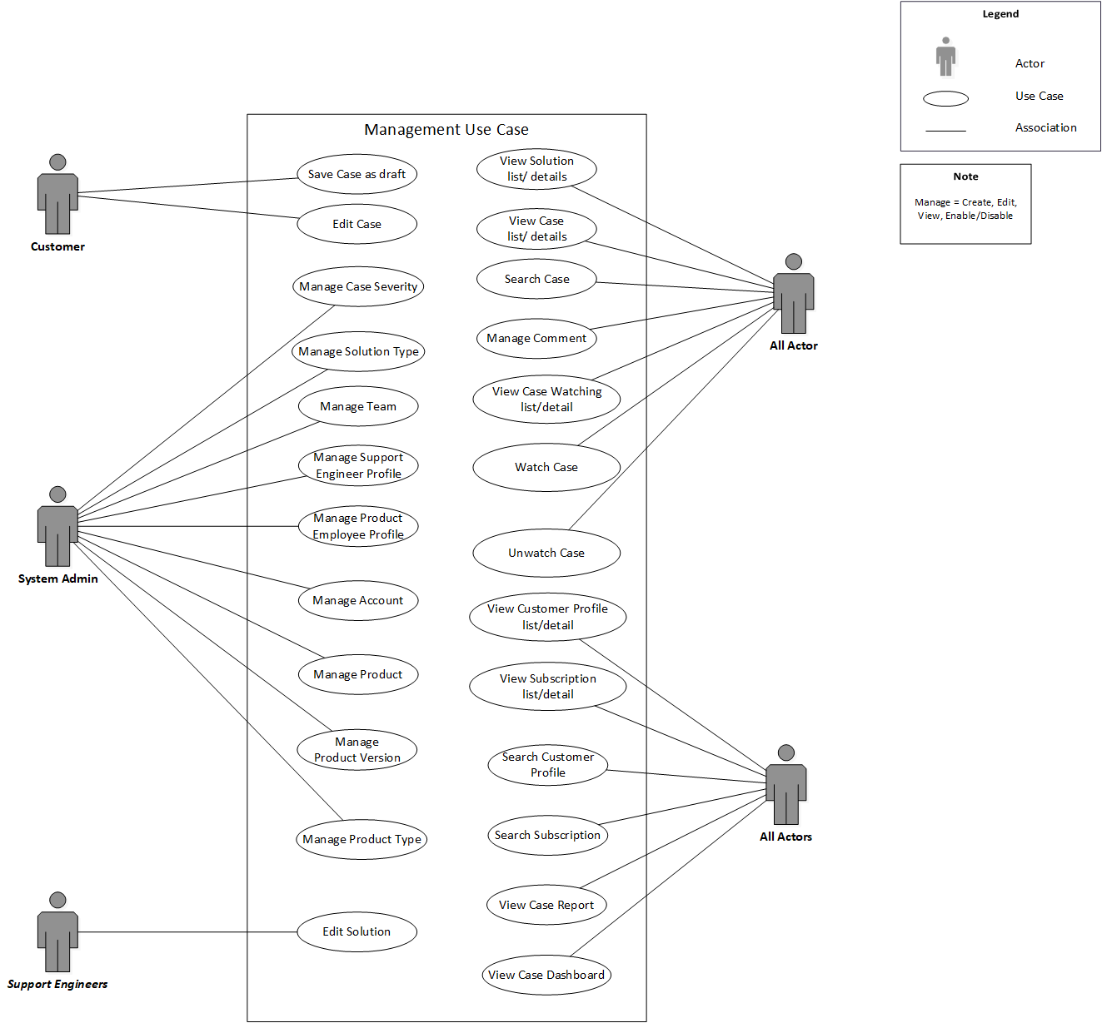
Figure 7: Manage Use Case Diagram
# | UC Name | Description
 | Save Case as draft | This function allows Customer to save new Case as draft.
 | Edit Case | This function allows Customer to edit a Case.
 | Manage Case Severity | This function allows System Admin to create, edit, view, search, enable and disable Case Severity.
 | Manage Solution Type | This function allows System Admin to create, edit, view, search, enable and disable Solution Type.
 | Manage Team | This function allows System Admin to create, edit, view, search, enable and disable Team.
 | Manage Support Engineer Profile | This function allows System Admin to create, edit, view, search, enable and disable Support Engineer Profile.
 | Manage Product Employee Profile | This function allows System Admin to create, edit, view, search, enable and disable Product Employee Profile.
 | Manage Account | This function allows System Admin to create, edit, view, search, enable and disable Customer’s Account.
 | Manage Product | This function allows System Admin to create, edit, view, search, enable and disable Product.
 | Manage Product Version | This function allows System Admin to create, edit, view, search, enable and disable Product Version.
 | Manage Product Type | This function allows System Admin to create, edit, view, search, enable and disable Product Type.
 | Edit Solution | This function allows Support Engineer L1, Support Engineer L2, Support Engineer L3 to edit their Solution.
 | View Solution list/detail | This function allows all the Accounts to view Solution list/detail.
 | View Case list/detail | This function allows all the Accounts to view Case list/detail.
 | Search Case | This function allows all the Accounts to search Cases.
 | Manage Comment | This function allows all the Accounts to create, edit, view, search and reply Comment.
 | View Case Watching list/detail | This function allows all the Accounts to view Solution list/detail.
 | Watch Case | This function allows all the Accounts to watch Case.
 | Unwatch Case | This function allows all the Accounts to unwatch Case.
 | View Customer Profile list/detail | This function allows All actors to view Customer Profile list/detail.
 | View Subscription list/detail | This function allows All actors to view Subscription list/detail.
 | Search Customer Profile | This function allows All actors to search Customer Profile.
 | Search Subscription | This function allows All actors to search Subscription.
 | View Case Report | This function allows All actors to view Case Report.
 | View Case Dashboard | This function allows All actors to view Case Dashboard

Other Use Case Diagram
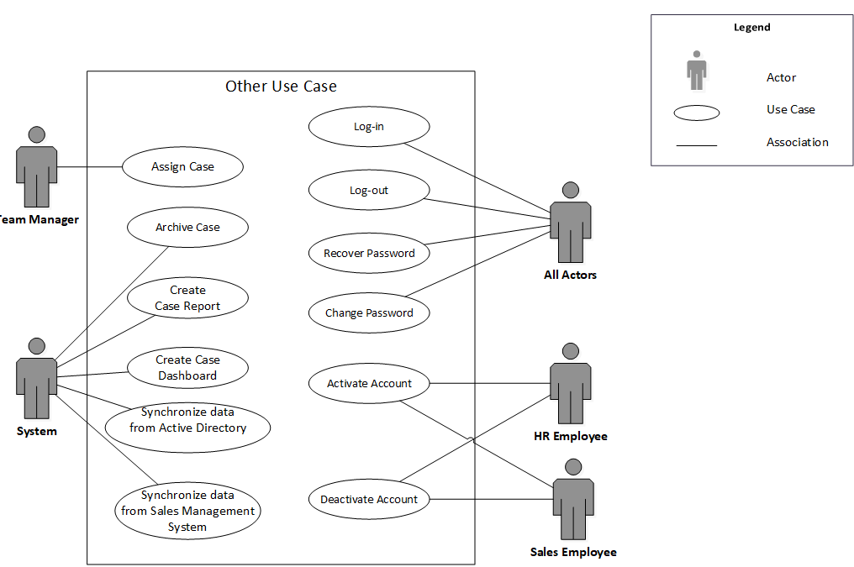
Figure 8: Other Use Case Diagram
# | UC Name | Description
 | Assign Case | This function allows System to assign a new Case to Support Engineer L1, Support Engineer L2, Support Engineer L3 and Team Manager to reassign to another Support Engineer.
 | Archive Case | This function allows System to Archive yearly all the closed Cases after 3 years.
 | Create Case Report | This function allows System to create Case Report.
 | Create Case Dashboard | This function allows System to create Case Dashboard.
 | Synchronize data from Sales Management System | This function allows System to synchronize data (Customer and Subscription data) from Sales Management System.
 | Synchronize data from Active Directory | This function allows System to synchronize data (Account of Employee) from Active Directory.
 | Log-in | This function allows all the Accounts to log-in to the system.
 | Log-out | This function allows all the Accounts to log-out from the system.
 | Recover Password | This function allows all the Accounts recover password.
 | Change Password | This function allows all the Accounts to change password.
 | Activate Account | This function allows System Admin to activate Account.
 | Deactivate Account | This function allows System Admin to deactivate Account.

Permission Matrix
Permission Matrix mapping functions and user roles for <<App Name>> application is described as below:
Remark:
“O” means that user has permission on corresponding function. For more information about what the actor can do on that function, please refer to corresponding use case.
“O*” means that user has permission on corresponding function on the item they created. For more information about what the actor can do on that function, please refer to corresponding use case.
“X” means that user does not have permission on corresponding function.
 | Actor 1 | Actor 2
Function 1
Function 2
e.g.
 | Customer | Support Engineer L1 | Support Engineer L2 | Support Engineer L3 | Developer | Team Manager | Product Manager | System Admin | System
Case
Submit Case | O* | X | X | X | X | X | X | X | X
Save Case as draft | O* | X | X | X | X | X | X | X | X
View Case list | O* | O** | O** | O** | O** | O** | O** | O | X
View Case detail | O* | O** | O** | O** | O** | O** | O** | O | X
Search Case | O* | O** | O** | O** | O** | O** | O** | O | X
Force Close Case | X | X | X | X | X | O** | X | O | X
Assign Case | X | X | X | X | X | O** | X | O | X
Archive Case | X | X | X | X | X | X | X | X | O
Watch Case | O* | O** | O** | O** | O** | O** | O** | O | X
Unwatch Case | O* | O* | O* | O* | O* | O* | O* | O* | X
Create Case Report | X | X | X | X | X | X | X | X | O
Create Case Dashboard | X | X | X | X | X | X | X | X | O
View Case Report | O** | O** | O** | O** | O** | O** | O** | O | X
View Case Dashboard | O** | O** | O** | O** | O** | O** | O** | O | X
Status is “Assigned”
Verify Case | X | O** | O** | X | X | X | X | O | X
Edit Case | O* | X | X | X | X | X | X | O | X
Close Case early | X | O** | O** | O** | X | X | X | O | X
Status is “ L1 Work In Progress”
Elevate Case | X | O** | X | X | X | X | X | O | X
Mark Case Pending | X | O** | X | X | X | X | X | O | X
Status is “ L2 Work In Progress”
Elevate Case | X | O** | X | X | X | X | X | O | X
Mark Case Pending | X | O** | X | X | X | X | X | O | X
Status is “ L3 Work In Progress”
Elevate Case | X | X | X | X | X | X | X | O | X
Mark Case Pending | X | O** | X | X | X | X | X | O | X
Status is “Pending Customer”
Provide Feedback | O** | X | X | X | X | X | X | O | X
Status is “Solution suggested”
Close Case | X | O** | O** | O** | X | X | X | O | X
Status is “Closed”
Reopen Case | O* | X | X | X | X | X | X | X | X
Comment
Create Comment | O** | O** | O** | O** | O** | O** | O** | O | X
Edit Comment | O* | O* | O* | O* | O* | O* | O* | O* | X
View Comment List | O** | O** | O** | O** | O** | O** | O** | O | X
View Comment Detail | O** | O** | O** | O** | O** | O** | O** | O | X
Search Comment | O** | O** | O** | O** | O** | O** | O** | O | X
Reply Comment | O** | O** | O** | O** | O** | O** | O** | O | X
Create private Comment | X | O** | O** | O** | O** | O** | O** | O | X
Edit private Comment | X | O* | O* | O* | O* | O* | O* | O* | X
View private Comment list | X | O** | O** | O** | O** | O** | O** | O | X
View private Comment detail | X | O** | O** | O** | O** | O** | O** | O | X
Solution
Save Solution as Draft | X | O* | O* | O* | X | X | X | O | X
Submit Solution | X | O* | O* | O* | X | X | X | O | X
Edit Solution | X | O* | O* | O* | X | X | X | O | X
View Solution list | O** | O* | O* | O* | O** | O** | O** | O | X
View Solution detail | O** | O* | O* | O* | O** | O** | O** | O | X
Search Solution | O** | O* | O* | O* | O** | O** | O** | O | X
Status is "Submitted"
Accept Solution | O** | X | X | X | X | X | X | X | X
Decline Solution | O** | X | X | X | X | X | X | X | X
Status is “Declined”
Accept declined Solution | O** | X | X | X | X | X | X | X | X
Case Watching
View Case Watching list | O** | O** | O** | O** | O** | O** | O** | O | X
View Case Watching details | O** | O** | O** | O** | O** | O** | O** | O | X
Product
Create Product | X | X | X | X | X | X | X | O | X
Edit Product | X | X | X | X | X | X | X | O | X
View Product list | O | O | O | O | O | O | O | O | X
View Product detail | O | O | O | O | O | O | O | O | X
Search Product | O | O | O | O | O | O | O | O | X
Enable Product | X | X | X | X | X | X | X | O | X
Disable Product | X | X | X | X | X | X | X | O | X
Customer Profile
Synchronize data from Sales Management System | X | X | X | X | X | X | X | X | O
View Customer Profile list | O | O | O | O | O | O | O | O | X
View Customer Profile details | O | O | O | O | O | O | O | O | X
Search Customer Profile | O | O | O | O | O | O | O | O | X
Team
Create Team | X | X | X | X | X | X | X | O | X
Edit Team | X | X | X | X | X | X | X | O | X
View Team list | X | X | X | X | O** | O** | X | O | X
View Team detail | X | O** | O** | O** | O** | O** | X | O | X
Search Team | X | X | X | X | x | O** | X | O | X
Enable Team | X | X | X | X | X | X | X | O | X
Disable Team | X | X | X | X | X | X | X | O | X
Account
Synchronize data from Active Directory | X | X | X | X | X | X | X | X | O
Create Account | X | X | X | X | X | X | X | O | X
Edit Account | X | X | X | X | X | X | X | O | X
View Account list | X | X | X | X | X | X | X | O | X
View Account detail | O** | O** | O** | O** | O** | O** | O** | O | X
Deactivate Account | X | X | X | X | X | X | X | O | X
Activate Account | X | X | X | X | X | X | X | O | X
Log-in | O** | O** | O** | O** | O** | O** | O** | O** | X
Log-out | O** | O** | O** | O** | O** | O** | O** | O** | X
Search Accounts | X | X | X | X | X | X | X | O | X
Recover Password | O** | O** | O** | O** | O** | O** | O** | O | X
Change Password | O** | O** | O** | O** | O** | O** | O** | O | X
Product Version
Create Product Version | X | X | X | X | X | X | X | O | X
Edit Product Version | X | X | X | X | X | X | X | O | X
View Product Version list | O | O | O | O | O | O | O | O | X
View Product Version detail | O | O | O | O | O | O | O | O | X
Search Product Version | O | O | O | O | O | O | O | O | X
Enable Product Version | X | X | X | X | X | X | X | O | X
Disable Product Version | X | X | X | X | X | X | X | O | X
Solution Type
Create Solution Type | X | X | X | X | X | X | X | O | X
Edit Solution Type | X | X | X | X | X | X | X | O | X
View Solution Type list | X | O | O | O | O | O | X | O | X
View Solution Type detail | X | O | O | O | O | O | X | O | X
Search Solution Type | X | O | O | O | O | O | X | O | X
Enable Solution Type | X | X | X | X | X | X | X | O | X
Disable Solution Type | X | X | X | X | X | X | X | O | X
Case Severity
Create Case Severity | X | X | X | X | X | X | X | O | X
Edit Case Severity | X | X | X | X | X | X | X | O | X
View Case Severity list | X | O | O | O | O | O | X | O | X
Search Case Severity | X | O | O | O | O | O | X | O | X
Enable Case Severity | X | O | O | O | O | O | X | O | X
Disable Case Severity | X | X | X | X | X | X | X | O | X
Subscription
Synchronize data from Sales Management System | X | X | X | X | X | X | X | X | O
View Subscription list | O** | O** | O** | O** | O** | O** | O** | O | X
View Subscription detail | O** | O** | O** | O** | O** | O** | O** | O | X
Search Subscription | O** | O** | O** | O** | O** | O** | O** | O | X
Product Type
Create Product Type | X | X | X | X | X | X | X | O | X
Edit Product Type | X | X | X | X | X | X | X | O | X
View Product Type list | O | O | O | O | O | O | O | O | X
View Product Type detail | O | O | O | O | O | O | O | O | X
Search Product Type | O | O | O | O | O | O | O | O | X
Enable Product Type | X | X | X | X | X | X | X | O | X
Disable Product Type | X | X | X | X | X | X | X | O | X

Site Map

Site Map for Customer Portal
The site map describes the way for navigating through the system.
<Template only: Note: Only need to draw up to 3 levels from the Home page to reduce the complexity and make the map readable.>
Figure 9: Site map for External Users (Customers)
Page | Description | Permission
Homepage | This screen summarizes list of all Cases created by the Customer logging in. Customer can create Case and view detail of each Case along with its corresponding Solutions from this page.  Link with <<cross reference to the corresponding screen>>. | Customer  System Admin  Link with Permission Matrix
Account Information | This screen summarizes information about account of user logging in.  Link with <<cross reference to the corresponding screen>>. | Customer  System Admin  Link with Permission Matrix
All Open Cases | This screen list out all Cases that have not been closed of the Company of current users.  Link with <<cross reference to the corresponding screen>>. | Customer  System Admin  Link with Permission Matrix
All Cases | This screen list out all Cases of the Company of current users.  Link with <<cross reference to the corresponding screen>>. | Customer  Link with Permission Matrix

Site Map for Internal Portal
The site map describes the way for navigating through the system.
<Template only: Note: Only need to draw up to 3 levels from the Home page to reduce the complexity and make the map readable.>
Figure 10: Site map for Internal Users
Page | Description | Permission
Homepage | This screen display dashboards which summarize information of Case, Solution, SLA and Product.  Link with <<cross reference to the corresponding screen>>. | All users  Link with Permission Matrix
Account Information | This screen summarizes information about account of user logging in.  Link with <<cross reference to the corresponding screen>>. | All users  Link with Permission Matrix
Case | This screen summarizes information about list of cases. Customer can create Case from this page.  Link with Screen 1: Case List | All users  Link with Permission Matrix
Product Management | This screen summarizes information about list of product.  Link with <<cross reference to the corresponding screen>>. | All users  Link with Permission Matrix
Customer Management | This screen summarizes information about Customer Profile.  Link with <<cross reference to the corresponding screen>>. | All users  Link with Permission Matrix
Account Management | This is just a menu, when user clicks on, the system will display sub-menu items. | All users  Link with Permission Matrix
Team | This screen summarizes information about team.  Link with <<cross reference to the corresponding screen>>. | All users  Link with Permission Matrix
Account | This screen summarizes information about account of all actors in the system.  Link with <<cross reference to the corresponding screen>>. | All users  Link with Permission Matrix
Master Data | This is just a menu, when user clicks on, the system will display sub-menu items. | All users  Link with Permission Matrix
Solution Type | This screen summarizes information about solution types.  Link with <<cross reference to the corresponding screen>>. | All users  Link with Permission Matrix
Case Severity | This screen summarizes information about case severity.  Link with <<cross reference to the corresponding screen>>. | All users  Link with Permission Matrix
Product Type | This screen summarizes information about product type.  Link with <<cross reference to the corresponding screen>>. | All users  Link with Permission Matrix

Use Case Specifications
This section covers the system’s functional requirements which details what the system must do in terms of input, behavior and the expected output. It elicits the interaction between the actor(s) and the system, the system’s behavior and the results of their interactions.

Customer Portal

UC 1: Submit Case
Objective: | This use case allows user to submit Case.
Actor: | Customer.
Trigger: | User clicks on “Create New Case” on <<cross reference to Case Listing screen>>.
Pre-condition: | Use logged in successfully as actor above.
Post-condition: | Case is submitted successfully.

Activities Flow
Business Rules
Step | BR Code | Description
(2) | BR 1 | Screen Displaying Rules:  The system will load screen: Screen 2: Case Form screen.
(4) | BR 2 | Confirmation Message Displaying Rules:  After the User clicks on “Submit” button, the system will display CFD 1 Are you sure you want to submit Case?.  - If User clicks on “No”, go to BR 1.  - If User clicks on “Yes”, go to BR 3.
(6) | BR 3 | Submitting Rules:  After the User clicks on “Yes” button:  - Create a new Case or update existing Case record as follows:  - In case a new Case is created, generate [Case ID] = “CA” + xxxxx  - CA: Prefix for Case.  - xxxxx: Auto-increment number from 00001 to 99999.  - Update [Assignee] to [Technical Employee ID] of {Technical Employee Profile} that satisfies:  - [Team ID] = [Team ID] of {Team} that satisfies [Product] = [Product] of current Case.  - [Role] is “Support Engineer”.  - [Level] is same as [Product Tier] of current Case.  - <Other rules for auto-assigning support engineer>  - Update [Status] to “Assigned”.  - Update [SLA]:  - If [Case Severity] is “Major issue”, update [SLA] to “1 day”.  - If [Case Severity] is “Medium issue”, update [SLA] to “3 days”.  - If [Case Severity] is “Minor issue”, update [SLA] to “5 days”.  - Save all changes.  - Refer to CBR1 to log basic audit trail.  - Append to [Audit Trail] as: Submitted by {Current User Name} at {Current Date Time}.  - The system will load screen: Case List Screen.  - The system will send an email ET 1: Sending email to Customer after submitting Case.

Internal Portal

UC 2: Approve Booking Request
Objective | This use case allows Receptionist to approve Booking Request submitted by Customer.
Actor | Receptionist
Trigger | - User clicks on “View Detail” button on reminder notification to approve a submitted booking request  - OR User clicks on “View Detail” button on the corresponding record in the table from screen <<cross reference to Booking Request List screen>>
Pre-conditions | User logged in successfully as actor above.
Post-condition | Booking Request is successfully approved

Activities Flow
Business Rules
Step | BR Code | Description
(2) | BR 4 | Screen Displaying Rules:  The system will load Screen: <<cross reference to Solution Form Screen>>.
(4) | BR 5 | Confirmation Message Displaying Rules:  After the User clicks on “Submit” button, the system will display CFD 2 Are you sure you want to submit Solution?.  - If User clicks on “No”, go to BR 4.  - If User clicks on “Yes”, go to BR 6.
(6) | BR 6 | Submitting Rules:  After the User clicks on “Yes” button:  - The system will create a new Solution record with:  - Update [Case ID] to [Case ID] of corresponding “Case”  - Update [Status] to “Submitted”  - Refer to CBR1 to log basic audit trail.  - Append to [Audit Trail] as: Submitted by {Current User Name} at {Current Date Time}.  - Save all changes.  - The system will load Screen: <<cross reference to Solution List Screen>>.  - The system will send an email ET 2: Sending email to Customer after Solution is submitted.

UC 3: Accept Solution
Objective | This use case allows User to accept Solution.
Actor | Customer.
Trigger | User clicks on “Accept” button on <<cross reference to View Solution details Screen>>.
Pre-conditions | - User logged in successfully as actor above.  - [Status] of Solution is “Submitted”.
Post-condition | Solution is accepted.

Activities Flow
Business Rules
Step | BR Code | Description
(2) | BR 7 | Screen Displaying Rules:  The system will load Screen: <<cross reference to View Solution details Screen>>.
(5) | BR 8 | Confirmation Message Displaying Rules:  After the User clicks on “Accept” button, the system will display CFD 2 Are you sure you want to submit Solution?.  - If User clicks on “No”, go to BR 7.  - If User clicks on “Yes”, go to BR 9.
(6) | BR 9 | Accepting Rules:  After the User clicks on “Yes” button:  - The system will update data of the current Solution as follows:  - Update [Status] to “Accepted”.  - Refer to CBR1 to log basic audit trail.  - Append to [Audit Trail] as: Accepted by {Current User Name} at {Current Date Time}.  - Save all changes.  - The system will update data of the current Solution as follows:  - Update [Status] to “Closed”.  - Refer to CBR1 to log basic audit trail.  - Append to [Audit Trail] as: Closed by {Current User Name} at {Current Date Time}.  - Save all changes.  - The system will load Screen: <<cross reference to Case Detail Screen>>.  - The system will send an email ET 3: Sending email to Support Engineer after Solution is accepted.

Manage Use Case

UC 4: Create Product
Objective: | This function allows user to create Product.
Actor: | System Admin
Trigger: | User clicks on “Create” button on <<cross reference to Product Listing Screen>>.
Pre-condition: | User logged in successfully as actor above.
Post-condition: | A new Product is successfully created.
Activity Flows
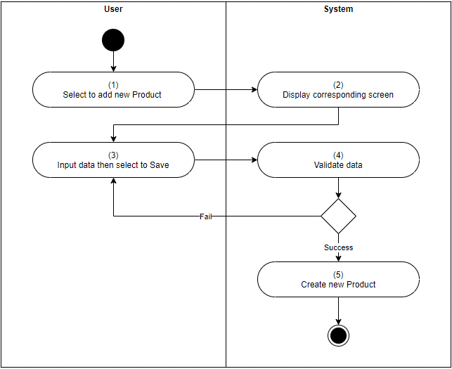
Business Rules
Step | BR Code | Description
(2) | BR 10 | Screen Displaying Rules:  The system will load Screen: <<cross reference to Create Product Screen>>.
(4) | BR 11 | Validating Rules:  The system will validate all the mandatory fields as stated in screen description.  - If any mandatory field is left blank, under the corresponding field, display inline error message IEM 1 Please input in this field.  - Otherwise, go to step 5.
(5) | BR 12 | Creating Rules:  After the User clicks on “Save” button:  - System will create a record in “Product” with:  - All inputted data.  - [Product Code] is generated as this format: PXX where XX is auto increasing number.  - Update [Status] as “Active”.  - Save all changes.  - Refer to CBR1 to log basic audit trail.  - The system will load screen: <<cross reference to Product Listing Screen>>.

UC 5: Edit Product
Objective: | This use case allows user to edit an existing Product.
Actor: | System Admin
Trigger: | User clicks on “Edit” button on <<cross reference to Product details Screen>>.
Pre-condition: | - User logged in successfully as actor above.  - [Status] of the Product is “Active”.
Post-condition: | Product is updated.

Activities Flow

Business Rules
Step | BR Code | Description
(2) | BR 13 | Screen displaying rules:  The system will load screen: <<cross reference to Edit Product Details Screen>>.
(4) | BR 14 | Validating Rules:  The system will validate all the mandatory fields as stated in screen description.  - If any mandatory field is left blank, under the corresponding field, display inline error message IEM 1 Please input in this field.  - Otherwise, go to step 5.
(4) | BR 15 | Updating Rules:  After the User clicks on “Save” button:  - Save all changes.  - Refer to CBR1 to log basic audit trail.  - The system will load screen: <<cross reference to Product Listing Screen>>.

UC 6: View an existing Product
Objective: | This use case allows user to view the details of a Product.
Actor: | All authenticated users.
Trigger: | User selects to open an existing Product on <<cross reference to Product List screen>>.
Pre-condition: | User logged in successfully as actor above.
Post-condition: | The detailed information of the selected Product is displayed.
Activities Flow
Business Rules
Step | BR Code | Description
(2) | BR 16 | Screen Displaying Rules:  The system will load screen: <<cross reference to Product Details screen>> of {Selected Product}.

UC 7: View List of existing Products
Objective: | This use case allows user to view list of existing Products.
Actor: | All authenticated users.
Trigger: | User selects to view list of existing Products.
Pre-condition: | User logged in successfully as actor above.
Post-condition: | The list of existing Products is displayed.
Activities Flow
Business Rules
Step | BR Code | Description
(2) | BR 17 | Screen Displaying Rules:  The system will load screen: <<cross reference to Product Listing screen>>.

UC 8: Disable an existing Product
Objective: | This use case allows user to disable a Product.
Actor: | System Admin
Trigger: | User clicks on “Disable” button on <<cross reference to Product Detail screen>>.
Pre-condition: | - User logged in successfully as actor above.  - [Status] of the Product is “Active”.
Post-condition: | The selected Product is disabled successfully.
Activities Flow
Business Rules
Step | BR Code | Description
(2) | BR 18 | Confirmation Message Rules:  The system will show confirmation message CFD 3 Are you sure you want to accept Solution?.  - If User clicks on “No”, cancel the action.  - If User clicks on “Disable”, go to Error! Reference source not found..
(4) | BR 19 | Disabling Rules:  - The system will update [Status] of the current Product to “Inactive”.  - The system will update [Status] of all open Case related to this Product to “Closed” (Open Case is Case with [Status] is not “Closed”).  - The system will load screen: <<cross reference to Product List screen>>.

Manage Line of Business
- Objective: This use case is used the common functions (Create, View, Update, Delete) to manage data.
- Actor: Accountant, System Admin.
- Common behavior and business rules: Refer to Common Use Cases for more details of common behavior and business rules, when creating, viewing, updating, deleting in this object.
- Business Rules:
Besides of business rules described in Common Use Cases, following rules are required for this object.
  - Creating new item Rules:
    - Validation rules:
      - <list of validation data rules if any>
  - Updating Rules:
    - Validation rules: <list of validation data rules if any>
  - Deleting rules:
      - <list of validation data rules if any>
- Screens: <list out list of screen>
  - For listing screen: <Refer to…>
  - For creation screen: <Refer to…>
  - For viewing screen: <Refer to…>
  - For updating screen: <Refer to…>

Other Use Case

UC 9: Search Case
Objective | This use case allows User to Search Case.
Actor | - Support Engineer L1  - Support Engineer L2  - Support Engineer L3,  - Developer  - Team Manager  - Product Manager  - System Admin
Trigger | User clicks on “Search” button on <<cross reference to the corresponding screen>>.
Pre-conditions | User logged in successfully as actor above.
Post-condition | Search results are displayed.
Activities Flow
Business Rules
Step | BR Code | Description
(1) | BR 20 | Display Rules:  - After the User inputs [Search criteria] and clicks on “Search” button, the System will display Case records that satisfy all the following conditions:  - Product scope:  - If user is not System Admin: Only return Cases belonging to the [Product] of the [Team] that user belongs to.  - If use is System Admin: return all Cases of any Product.  - AND [Case ID] contains the keyword inputted in [Case ID].  - AND [Customer] equal to the inputted [Customer].  - AND [Title] contains the keyword inputted in [Title].  - If there is no Case satisfying the matching conditions, the System will display <<cross reference to Failed Search Result Screen>>.  - If there is Case satisfying the matching conditions, return the matching Cases, sorted based on relevance. <Rules defining Relevance of matching results>

Scheduled Job

UC 10: Close Case without Customer Feedback
Objective | This use case is to automatically close Case without Customer Feedback for a specific time.
Actor | System.
Trigger | 3:00 AM (GMT+0 time zone) every day.
Pre-conditions | N/A
Post-condition | Case without Customer Feedback for a pre-defined time is Closed.

Activities Flow
Business Rules
Step | BR Code | Description
(1) | BR 21 | Auto-Closing Rule:  The system will update [Status] of the Case that satisfies that satisfies the following conditions to “Close”:  - [Status] is “Pending Customer” and it is more than 30 days from the day when the [Status] is changed.  - OR [Status] is “Solution Suggested” it is more than 45 days from the day when the [Status] is changed.  - Send an email ET 4: Sending Email to System Admin of auto-closing Cases.

Common Use Cases
This is the list of standard system functions that allows users to work with an object in the system. Each function provides a typical business rule and how authorised users interact with the system to achieve the function's goal.
The list consists of:
- Create Item
- View Item
- Update Item
- Delete Item

CMUC 1: View list of Items
Objective: | This function allows user to view list of items.
Actor: | Refer to use case that using this common use case.
Trigger: | User selects to view list of items
Pre-condition: | User logged in successfully as actor above.
Post-condition: | List of items is displayed for viewing.
Activity Flows
Business Rules
Step | BR Code | Description
(2) | BR 22 | Screen Displaying Rules:  The system will load the corresponding screen for listing items.

CMUC 2: Create Item
Objective: | This function allows user to create a new item.
Actor: | Refer to use case that using this common use case.
Trigger: | User clicks on button to create item.
Pre-condition: | User logged in successfully as actor above.
Post-condition: | A new item is successfully created.
Activity Flows
Business Rules
Step | BR Code | Description
(2) | BR 23 | Screen Displaying Rules:  The system will load the corresponding screen at the new mode.
(4)  (4.1) | BR 24 | Validating Rules:  After user clicks on “Save” button, the system will validate all the mandatory fields as stated in screen description.  If any mandatory field is left blank, under the corresponding field, display inline error message IEM 1 Please input in this field.
(4.2) | BR 25 | Creating Rules:  After passing the validation rules, the system will create a new item as below:  - Save all inputted data.  - Update audit trail of new item as CBR1 to log basic audit trail.  - The system will re-direct user to the previous screen.

CMUC 3: Read Item
Objective: | This use case allows user to view the details of a selected Item.
Actor: | Refer to use case that using this common use case.
Trigger: | User selects to open an existing item.
Pre-condition: | User logged in successfully as actor above.
Post-condition: | The selected item is opened for viewing.
Activity Flows
Business Rules
Step | BR Code | Description
(2) | BR 26 | Screen Displaying Rules:  The system will load the corresponding screen at the view mode.

CMUC 4: Update Item
Objective: | This use case allows user to update an existing Item.
Actor: | Refer to use case that using this common use case.
Trigger: | User selects to edit an existing Item then selects to Save.
Pre-condition: | User logged in successfully as actor above.
Post-condition: | The Item is updated successfully.
Activity Flows
Business Rules
Step | BR Code | Description
(2) | BR 27 | Screen Displaying Rules:  The system will load the corresponding screen at the new mode.
(4)  (4.1) | BR 28 | Validating Rules:  After user clicks on “Save” button, the system will validate all the mandatory fields as stated in screen description.  If any mandatory field is left blank, under the corresponding field, display inline error message IEM 1 Please input in this field.
(4.2) | BR 29 | Updating Rules:  After passing the validation rules, the system will create a new item as below:  - Save all changes data.  - Update audit trail of new item as CBR1 to log basic audit trail.  - The system will re-direct user to the previous screen.

CMUC 5: Delete Item
Objective: | This use case allows user to delete an existing Item.
Actor: | Refer to use case that using this common use case.
Trigger: | User selects to delete an existing Item.
Pre-condition: | User logged in successfully as actor above.
Post-condition: | The selected Item is deleted successfully.
Activity Flows
Business Rules
Step | BR Code | Description
(2) | BR 30 | Confirmation Rules:  The system shows a confirmation message CFD 5 Are you sure you want to delete this item? with two buttons “OK” and “Cancel”.
(4) | BR 31 | Deleting Rules:  - If user clicks on the “OK” button from the confirmation dialog, system will move the selected Item to the Recycle Bin/flag the document as deleted/delete the item permanently.  - If user clicks on the “Cancel” button, system will close the confirmation dialog and do nothing.

Common Business Rules
This section defines business rules that are used across use cases and can be considered as common rules. Each common business rule below is applied only for use cases that have reference to it.
BR Code | Description
CBR1 | Logging Basic Audit Trail Rule:  - When the record is created:  - Update [Created by] to [User ID] of {Current Login User}.  - Update [Created at] to current date time.  - When the record is created or updated:  - Update [Last modified by] to [User ID] of {Current Login User}.  - Update [Last modified at] to current date time.

Mockups Screen
This section contains the screens and their respective attributes associated with one or more use cases defined in Site Map
Site Map for Customer Portal
The site map describes the way for navigating through the system.
<Template only: Note: Only need to draw up to 3 levels from the Home page to reduce the complexity and make the map readable.>
Figure 9: Site map for External Users (Customers)
Page | Description | Permission
Homepage | This screen summarizes list of all Cases created by the Customer logging in. Customer can create Case and view detail of each Case along with its corresponding Solutions from this page.  Link with <<cross reference to the corresponding screen>>. | Customer  System Admin  Link with Permission Matrix
Account Information | This screen summarizes information about account of user logging in.  Link with <<cross reference to the corresponding screen>>. | Customer  System Admin  Link with Permission Matrix
All Open Cases | This screen list out all Cases that have not been closed of the Company of current users.  Link with <<cross reference to the corresponding screen>>. | Customer  System Admin  Link with Permission Matrix
All Cases | This screen list out all Cases of the Company of current users.  Link with <<cross reference to the corresponding screen>>. | Customer  Link with Permission Matrix

Site Map for Internal Portal
The site map describes the way for navigating through the system.
<Template only: Note: Only need to draw up to 3 levels from the Home page to reduce the complexity and make the map readable.>
Figure 10: Site map for Internal Users
Page | Description | Permission
Homepage | This screen display dashboards which summarize information of Case, Solution, SLA and Product.  Link with <<cross reference to the corresponding screen>>. | All users  Link with Permission Matrix
Account Information | This screen summarizes information about account of user logging in.  Link with <<cross reference to the corresponding screen>>. | All users  Link with Permission Matrix
Case | This screen summarizes information about list of cases. Customer can create Case from this page.  Link with Screen 1: Case List | All users  Link with Permission Matrix
Product Management | This screen summarizes information about list of product.  Link with <<cross reference to the corresponding screen>>. | All users  Link with Permission Matrix
Customer Management | This screen summarizes information about Customer Profile.  Link with <<cross reference to the corresponding screen>>. | All users  Link with Permission Matrix
Account Management | This is just a menu, when user clicks on, the system will display sub-menu items. | All users  Link with Permission Matrix
Team | This screen summarizes information about team.  Link with <<cross reference to the corresponding screen>>. | All users  Link with Permission Matrix
Account | This screen summarizes information about account of all actors in the system.  Link with <<cross reference to the corresponding screen>>. | All users  Link with Permission Matrix
Master Data | This is just a menu, when user clicks on, the system will display sub-menu items. | All users  Link with Permission Matrix
Solution Type | This screen summarizes information about solution types.  Link with <<cross reference to the corresponding screen>>. | All users  Link with Permission Matrix
Case Severity | This screen summarizes information about case severity.  Link with <<cross reference to the corresponding screen>>. | All users  Link with Permission Matrix
Product Type | This screen summarizes information about product type.  Link with <<cross reference to the corresponding screen>>. | All users  Link with Permission Matrix

Use Case Specifications section above.

Customer Portal

Case List Screen
- This screen allows Customer to view List of existing Cases created by him.
- Customer can access this screen by logging in the system.
  - Step 1: Log in the system.
  - Step 2: Click on module “All Open Cases” in Navigation Pane in the left.
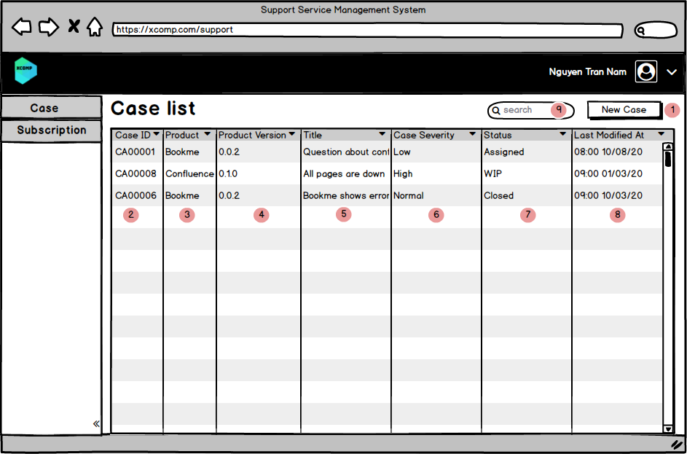
Screen 1: Case List screen
Data Source | <Describe getting data from which objects with which conditions when user opens this screen by default>  Retrieve all “Case” records satisfying  - [Customer ID] is the same as [Customer ID] of {current user logging in}.  - [Status] is not “Closed”.
Default Sorting | <Default sorting when opening this screen>  Sorted by [Case ID] in descending order.

# | Component | Component Type | Description
 | New Case | Button | - This button allows Customer to create a new case.  - Refer to UC 2: Submit Solution.
 | Search Bar | Retrieve from [Case Severity] of corresponding Case. | Refer to <TBD>.
 | Case ID | Retrieve from [Case ID] of corresponding Case. | Link to item: Case details screen of this Case ID.
 | Product | Column Header | Retrieve from [Product] of corresponding Case.
 | Product Version | Column Header | Retrieve from [Product] of corresponding Case.
 | Title | Column Header | Retrieve from [Title] of corresponding Case.
 | Case Severity | Column Header | Retrieve from [Case Severity] of corresponding Case.
 | Status | Column Header | Retrieve from [Status] of corresponding Case, display as:  - “Pending Customer” if [Status] is “Pending Customer” or “Solution Suggested”.  - “Closed” if [Status] is “Closed”.  Otherwise, display as “In Progress”.

Create Case Screen
- This screen allows user to Save case as Draft or Submit Case.
- User can access this screen by: Click on “New case” on screen <TBD>.
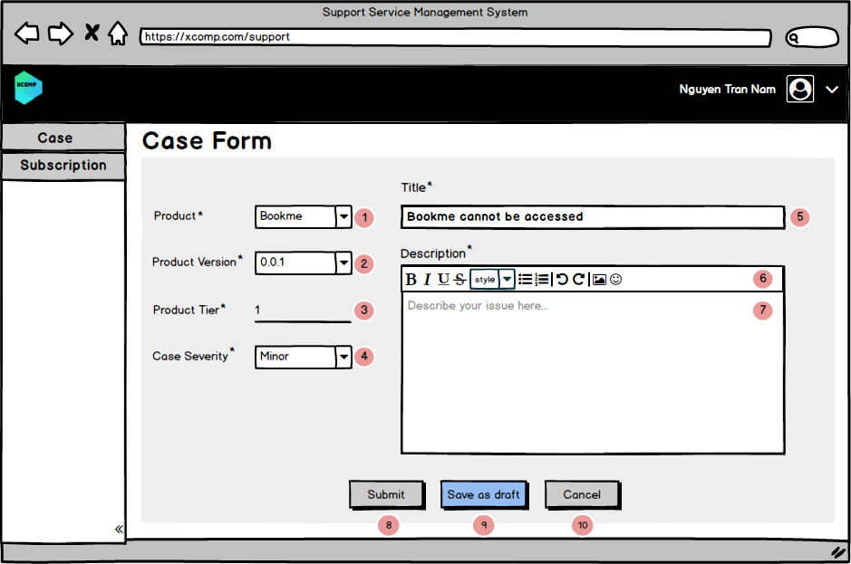
Screen 2: Case Form screen
# | Component | Comp. Type | Editable | Mandatory | Default Value | Description
 | Product | Dropdown list | Yes | Yes | N/A | - Value list: Retrieve all [Product] in “Subscription” that qualifies:  - [Customer ID] is the same as [Customer ID] of {current user logging in}  - And [Disable] is “Unchecked”.  - Sorting: Alphabetic order.
 | Product Version | Dropdown list | Yes | Yes | N/A | - Value list: Retrieve all [Product Version Name] in “Product Version” that qualifies:  - [Product ID] equal [Product ID] of {selected Product}  - and [Disable] is “Unchecked”.  - Sorting: Ascending order of [Release Datetime].
 | Product Tier | Label | N/A | N/A | N/A | Retrieve [Product Tier] in “Subscription” that qualifies all below conditions:  - [Customer ID] is [Customer ID] of {Current user logging in}  - [Product ID] is [Product ID] of {selected Product}  - [Product Version ID] is [Product Version ID] of {selected Product Version}.
 | Case Severity | Dropdown list | Yes | Yes | N/A | - Value list: Retrieve all [Case Severity Name] in “Case Severity” that qualifies [Disable] is “Unchecked”.  - Sorting: Alphabetic order.
 | Title | Single Line of Text | Yes | Yes | N/A | - User inputs Title of Case.  - Max Length: 50 characters.  - When user loses focus of this field and this field is left blank, display IEM 1 Please input in this field.
 | Toolbar | N/A | N/A | N/A | N/A | This allows Customer to format text in field [Description].  <<refer to other part of the document that describes detail about all the functions in this Toolbar>>
 | Description | Multi lines of text | Yes | Yes | N/A | - User inputs Description of Case.  - Max Length: 2000 characters  - When user loses focus of this field and this field is left blank, display IEM 1 Please input in this field.
 | Submit | Button | N/A | N/A | N/A | - This button allows user to submit Case.  - Default is Disabled.  - If all Mandatory fields are filled, the button is enabled.  - Refer to UC 1: Submit Case.
 | Save as draft | Button | N/A | N/A | N/A | This button allows user to save Case as draft, refer to <<cross reference to the corresponding use case>>
 | Cancel | Button | N/A | N/A | N/A | This button allows user to cancel the action.

Internal Portal

Case Detail Screen
- This screen allows user to view details of a Case.
- User can access this screen by:
  - Step 1: Log in the system
  - Step 2: Click on one of Cases in Case List Screen
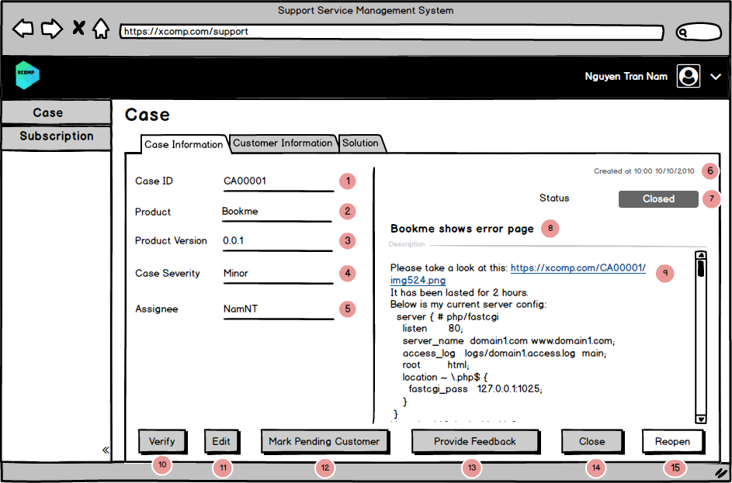
Screen 3: Case Details screen
# | Component | Comp. Type | Editable | Mandatory | Default Value | Description
 | Case ID | Label | N/A | N/A | N/A | Retrieve [Case ID] from the corresponding Case.
 | Product | Label | N/A | N/A | N/A | Retrieve [Product] from the corresponding Case.
 | Product Version | Label | N/A | N/A | N/A | Retrieve [Product Version] from the corresponding Case.
 | Severity | Label | N/A | N/A | N/A | Retrieve [Severity] from the corresponding Case.
 | Assignee | Label | N/A | N/A | N/A | - Retrieve [Assignee] from the corresponding Case.  - Refer to BR 3.
 | Created at | Label | N/A | N/A | N/A | - Retrieve [Created at] from the corresponding Case.  - Time format: HH:MM DD/MM/YYYY
 | Status | Label | N/A | N/A | N/A | Retrieve [Status] from the corresponding Case.
 | Title | Label | N/A | N/A | N/A | Retrieve [Title] from the corresponding Case.
 | Description | Label | N/A | N/A | N/A | Retrieve [Description] from the corresponding Case.
 | Verify | Button | N/A | N/A | N/A | - This button allows user to verify case, refer to <<cross reference to the corresponding use case>>  - Enable when:  - [Status] of the corresponding Case is “Assigned”.  - [Role] of current user is …
 | Edit | Button | N/A | N/A | N/A | - This button allows user to edit case.  - Default is enable.  - Button is disable when Case is closed.  Clicking on “Reopen” button will trigger UC: Edit Case.
 | Mark Pending Customer | Button | N/A | N/A | N/A | - This button allows user to mark Case as pending customer, refer to <<cross reference to the corresponding use case>>  - Enable when:  - [Status] of the corresponding Case is “L1/L2/L3 Working in Progress”  - [Role] of current user is …

Non-Functional Requirements
This section describes the operation of the system with respect to the Performance Requirements (optional)
< Template only: If there are performance requirements for the product under various circumstances, state them here and explain their rationale, to help the developers understand the intent and make suitable design choices. Specify the timing relationships for real time systems. Make such requirements as specific as possible. You may need to state performance requirements for individual functional requirements or features.>

Performance requirements refer to the capability of the software to provide the required performance relative to the amount of resources used, under stated conditions
Title | Variables / Criteria | Remarks
Response Time | - Measurement Point.  - Statistic Type.  - Measurement Period.  - Platform.  - Error Rate. | i.e. Number of operations performed per second.  i.e. The system shall be able to process 100 payment transactions per second in peak load  i.e. Production of a simple report shall take less than 20 seconds for 95% of the cases.  i.e. Scrolling one page up or down in a 200 page document shall take at most 1 second.
Workload | - Workload percentage at peak time.  - Workload percentage at off-peak time. | i.e. In standard workload, the CPU usage shall be less than 50%, leaving 50% for background jobs.
Scalability | Ease of Scalability.
Platform | - Hardware.  - Software.  - External System Integration. | - Operating systems:  - Windows: latest + 2 previous versions.  - Mac OS: latest + 2 previous versions.  - Devices:  - Mobile.  - Tablet.  - Desktop.

Performance Requirements (optional)
< Template only: If there are performance requirements for the product under various circumstances, state them here and explain their rationale, to help the developers understand the intent and make suitable design choices. Specify the timing relationships for real time systems. Make such requirements as specific as possible. You may need to state performance requirements for individual functional requirements or features.>

Performance requirements refer to the capability of the software to provide the required performance relative to the amount of resources used, under stated conditions
Title | Variables / Criteria | Remarks
Response Time | - Measurement Point.  - Statistic Type.  - Measurement Period.  - Platform.  - Error Rate. | i.e. Number of operations performed per second.  i.e. The system shall be able to process 100 payment transactions per second in peak load  i.e. Production of a simple report shall take less than 20 seconds for 95% of the cases.  i.e. Scrolling one page up or down in a 200 page document shall take at most 1 second.
Workload | - Workload percentage at peak time.  - Workload percentage at off-peak time. | i.e. In standard workload, the CPU usage shall be less than 50%, leaving 50% for background jobs.
Scalability | Ease of Scalability.
Platform | - Hardware.  - Software.  - External System Integration. | - Operating systems:  - Windows: latest + 2 previous versions.  - Mac OS: latest + 2 previous versions.  - Devices:  - Mobile.  - Tablet.  - Desktop.

Safety Requirements (optional)
<Template only: Specify those requirements that are concerned with possible loss, damage, or harm that could result from the use of the product. Define any safeguards or actions that must be taken, as well as actions that must be prevented. Refer to any external policies or regulations that state safety issues that affect the product’s design or use. Define any safety certifications that must be satisfied.>

Safety Requirement refers to the aspects of a solution that protects solution contents or solution components from accidental or malicious access, use, modification, destruction, or disclosure.

Title | Variables / Criteria | Remarks
Authenticity | Mode of authentication
Privacy | Password and message encryption | i.e. The system needs to follow standard encryption algorithm called DES (Data Encryption Standard).

Security Requirements (optional)
< Template only: Specify any requirements regarding security or privacy issues surrounding use of the product or protection of the data used or created by the product. Define any user identity authentication requirements. Refer to any external policies or regulations containing security issues that affect the product. Define any security or privacy certifications that must be satisfied.>

Title | Variables / Criteria | Remarks
Authentication | - Success rate in authentication.  - Resistance to known attacks.  - Probability/time/resources to detect an attack.  - Percentage of useful services still available during an attack.  - Percentage of successful attacks.  - Lifespan of a password, of a session.  - Encryption level. | i.e. The application shall identify all of its client applications before allowing them to use its capabilities.  i.e. The application shall ensure that the name of the employee in the official human resource and payroll databases exactly matches the name printed on the employee’s social security card.  i.e. At least 99% of intrusions shall be detected within 10 seconds.

Software Quality Attributes (optional)
< Template only: Specify any additional quality characteristics for the product that will be important to either the customers or the developers. Some to consider are: adaptability, availability, correctness, flexibility, interoperability, maintainability, portability, reliability, reusability, robustness, testability, and usability. Write these to be specific, quantitative, and verifiable when possible. At the least, clarify the relative preferences for various attributes, such as ease of use over ease of learning.>

Title | Variables / Criteria | Remarks
Usability: Ease with which a user can learn to use the solution.
Accessibility | - Color-blind users  - Voice-over for hearing impaired users
Internationalisation | - Time zone adaptation.  - Support multiple currencies.  - Support multiple languages. | The webpage must support 03 languages: English, Chinese, Korean.
Ease of Use | - Maximum number of clicks to complete any operation.  - Learnability.  - Efficiency.  - Memorability.  - Error Avoidance.  - User Satisfaction. | i.e. Assure maximum 04 clicks to complete a transaction.  i.e. Four out of five users shall be able to book a guest within 5 minutes after a 2-hour introduction to the system.  i.e. Novice users shall perform tasks X and Y in 15 minutes. Experienced users shall perform tasks X and Y in 2 minutes.  i.e. At least 80% of customers polled after a 3 months usage period shall rate their satisfaction with the system at 7 and more on a scale of 1 to 10.
Reliability: Ability of a solution or component to perform its required functions under stated conditions.
Availability | Percentage of time available | i.e. The system must be available 98% of time on a monthly basis.  i.e. No more than 1 per 1000000 transactions shall result in a failure requiring a system restart.  i.e. The system shall meet or exceed 99.99% uptime.  i.e. The system shall not be unavailable more than 1 hour per 1000 hours of operation.  i.e. Less than 20 seconds shall be needed to restart the system after a failure 95% of the time. (This is a MTTR requirement)
Backup | Backup frequency | Backup must be triggered every three days at 12:00AM.
Functional Suitability: Degree to which the solution functions meet user needs
Accuracy | Accuracy Rate | i.e. The precision of calculations shall be at least 1/106.  i.e. The system defect rate shall be less than 1 failure per 1000 hours of operation.
Completeness | Completeness Percentage
Compliance: Regulatory, financial, or legal constraints which can vary based on the context or jurisdiction.
Regulatory Compliance | Data Protection | The system must conform to the GDPR regulations.  - EU: GDPR  - Canada: PIPEDA
Constraint: Constraints of the organization being served by the solution that are formally agreed to by both the provider and the user of the solution.
Price | - Target price for the solution  - Limit for extensions  - Subscription allowance
Timeline | Release duration | Short releases – every 3 to 4 weeks

Other Requirements

Common field controls
<Template only: It is recommended that this part of the requirement refers directly to the library used by the development team. But in case that is not an option, please use the following section. Reference to embedded file.>

Common Messages Configuration
Message Type | Remarks
In-line Error Message | - Display in red italic text.  - Display below error field.  - Highlight error field in red.  - Message is displayed when there is error in validation.
In-field Error Message | - Display in red italic text.  - Display inside error field, completely cover the content of the field.  - Upon selecting the field, the message disappears and the content is displayed again.  - Highlight error field in red.  - Message is displayed when there is error in validation.  - Sample:  - 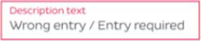.  - Where Description Text is the placeholder.  - “Wrong entry / Entry required” is the message content.
Error Message | - Pop-Up contains only message content and a button “Close”.  - Clicking outside of the pop-up does not close it, only button “Close” on the pop-up does.  - After closing popup, return to the current screen.  - Message is displayed when there is error in validation.
Confirmation Message | - Pop-Up contains only message content and two buttons “Yes”, “No”.  - Clicking outside of the pop-up does not close it, only button “Yes” or “No” does.  - After closing popup, performs the corresponding function or action, which is described specifically in each place using the Pop-up Confirmation Message.  - Message is displayed when there needs a confirmation of action.
Informing Message | - Pop-Up contains only message content and will disappear after 10s.  - Message is displayed after the system successfully performs a certain function or action.
Standard platform Message | Any standard platform message can be presented here.

View Columns Display
<Template only: It is recommended that this part of the requirement refers directly to the library used by the development team, or get suggestions from design team. But in case those are not viable options, please use the following section>
Unless otherwise stated, view columns’ display specifications are:
- Displayed color & fonts are as specified in approved screen designs.
- When the text to be displayed is longer than the width of cell, cut the text at the end of first line, and replace the missing characters with “…”. Hovering mouse over this “…” will pop up a tooltip at mouse position that displays full content of the respective cell.
- Unless otherwise stated, view columns’ headers are:
- Is unsorted by default.
- When unsorted, show icon as follows: 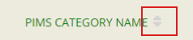
- When sorted in ascending, show icon as follows: 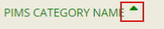
- When sorted in descending, show icon as follows: 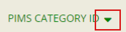

Pagination
<Template only: Parts of this segment will vary depends on pagination settings used by the current system. Please check and update accordingly>
Unless stated otherwise, pagination-related behavior in all views of the system will follow the following specifications:
- When user performs a new search (both completely new and searching within the current search results), refresh table, go back to page 1.
- When user changes the pagination setting (number of items to show per page), refresh table, go back to page 1.
- When user is in page 1, disable buttons of “<<” and “<”
- When user is in the last page, disable buttons of “>>” and “>”
- Otherwise, enable all buttons.
- Button “<” and “>” move the pagination backward or forward by 1.
- Button “<<” or “>>” move the pagination to page 1 or the last page.
- If there is 1 page, still display the pagination with 1 page.
- On the most left position, the system displays all records found that satisfied the current condition (display all or searched or filtered, etc…).
- User can input the number of pagination they want to go to, next to the total number of pagination.
- Sample: 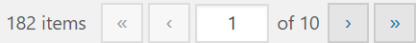

Search Component
<Template only: Parts of this segment will vary depends on search settings used by the current system. Please check and update accordingly>
Unless stated otherwise, search-related behavior in all views of the system will follow the following specifications:
- Search field is a Free Text (single line of text) field, thus it follows this field’s common properties.
- Search behavior follows “contain” logic, where the system searches all presenting columns for records that have value containing the keyed in value.
- Searched results are presented by refreshing the table listing information and the system updates pagination information accordingly.
- If keyed in value is blank, the system will reset to the default view information.

Bulk Action
<Template only: Parts of this segment will vary depends on Bulk Action settings used by the current system. Please check and update accordingly>
Unless stated otherwise, Bulk Action behavior in all views of the system will follow the following specifications:
- In the table listing, the first column will always be a checkbox columns allowing user to select records/items to apply Bulk Action.
- Selecting the checkbox on Column Header will select all checkboxes only on the current pagination of the table listing.
- Upon jumping between pagination, the selected state of checkboxes is kept.
- Users can select Bulk Action from the Dropdown list or available bulk action buttons (depending on the system) to apply to the selected items.
- For Dropdown List Bulk Action:
- Bulk Action is the default option, which performs nothing when apply.
- Value list contains:
  - Bulk Action.
  - Export.
  - Delete.
- For available bulk action buttons:
- These buttons are enable only when at least 1 checkbox is selected.
- Button includes:
  - Delete.
  - Export.

Integration
<Template only: Describe external system(s) which integrates with the system>

Data Migration
<Template only: Describe data migration scope and requirements.
In case SRS for data migration in a separated SRS, note down this point: e.g. Detailed requirements for Data Migration part will be described on separated SRS. The data migration SRS and the functional SRS will be a couple of documents to fulfil the whole requirements for SSS migration.>

Migration Scope
<Template only: This section is to define the scope of data migration. It contains the list of data objects or the specific condition to define the set of data which will be migrated.>

Data Mapping
<Template only: This section shows the mapping for migrated data. It contains the data properties on the old platform and the corresponding properties on the new platform. Data conversion and data patching rules are also described if any.>

Appendices

Messages List

Error Message
Message prompt in a pop up with:
- Title: "Error Message"
- Content: <Message>
- Button: OK. When user click on Ok button, the pop-up will be closed.
<Code> | <Code> <Message>
EMSG 1 | EMSG 1 You must specify a value for this required field.
EMSG 2 | EMSG 2 The import file must be XLS file.
EMSG 3 | EMSG 3 The data format of import file is not correct.
EMSG 4 | EMSG 4 Are you sure, you want to send the item(s) to the site Recycle Bin?
EMSG 5 | EMSG 5 You have approved leave request successfully.

Inline Error Message
Message prompts in red under the field that does not pass validation.
<Code> | <Code> <Message>
IEM 1 | IEM 1 Please input in this field.
IEM 2 | IEM 2 This name is already existed.
IEM 3 | IEM 3 You must specify a unique value for this field.

Confirmation Dialog
Message prompts in in a dialog with:
- Title: "Confirmation".
- Content: <Message>
- Button:
- Yes/OK: When user click on Yes/OK button, the system will close the pop-up and continue to perform the action.
- No/Cancel: The system will close the pop-up and cancel the action.
<Code> | <Code> <Message>
CFD 1 | CFD 1 Are you sure you want to submit Case?
CFD 2 | CFD 2 Are you sure you want to submit Solution?
CFD 3 | CFD 3 Are you sure you want to accept Solution?
CFD 4 | CFD 4 Are you sure you want to cancel?
CFD 5 | CFD 5 Are you sure you want to delete this item?

Success Dialog
Message prompts in in a dialog with:
- Title: "Success Dialog".
- Content: <Message>
- Include button “OK”.
- This dialog will be prompted and closed automatically after 5s.
<Code> | <Code> <Message>
SCD 1 | SCD 1 A new User Profile has been created.
SCD 2 | SCD 2 The User Profile has been updated.
SCD 3 | SCD 3 A new Video has been uploaded.
SCD 4 | SCD 4 A new Quiz has been created.
SCD 5 | SCD 5 A new Smart video has been created.

Email Templates
<Template only: It is recommended that Email Template Contents are written in Past Tense instead of Present Tense to be more formal. Define any Prefix necessary for the Email>.

ET 1: Sending email to Customer after submitting Case
Send to | Customer
CC | Assigned Support Engineer, Assigned Team Manager
Subject | [XCOMP] <Case ID> has been assigned to Software Engineer.
Body | Dear <Customer Name>,  <Case ID> has been successfully submitted and assigned to Software Engineer <Software Engineer Name> for processing.  To view Case details, please click here.  Sincerely,  Note: This is an auto-generated email, please do not reply.
Note:
- Customer: [Email] of Customer Profile that satisfies [Customer ID] = [Customer ID] of current Case.
- Assigned Support Engineer: [Email] of Technical Employee Profile that satisfies [Technical Employee Profile ID] = [Assignee] of current Case.
- Assigned Team Manager: [Email] of Technical Employee Profile that satisfies
- [Team ID] = [Team ID] of Technical Employee Profile that satisfies [Technical Employee ID] = [Assignee] of current Case.
- [Account ID] = [Account ID] of Account that satisfies [Role] = “Team Manager”.
- Case ID: [Case ID] of current Case.
- Customer Name: [Name] of Customer Profile that satisfies [Customer ID] = [Customer ID] of current Case.
- Software Engineer Name: [Name] of Technical Employee Profile that satisfies [Technical Employee ID] = [Assignee] of current Case.
- The link here leads to screen <Reference here>.

ET 2: Sending email to Customer after Solution is submitted
Send to | Customer
CC | Assigned Support Engineer, Assigned Team Manager
Subject | [XCOMP] Solution for <Case ID> has been submitted.
Body | Dear <Customer Name>,  Solution for <Case ID> has been submitted.  Please review and proceed to accept/decline Solution here.  Sincerely,  Note: This is an auto-generated email, please do not reply.
Note:
- Customer: [Email] of Customer Profile that satisfies [Customer ID] = [Customer ID] of Case corresponding to Current Solution.
- Assigned Support Engineer: [Email] of Technical Employee Profile that satisfies [Technical Employee ID] = [Technical Employee ID] of current Solution.
- Assigned Team Manager: [Email] of Technical Employee Profile that satisfies:
- [Team ID] = [Team ID] of Technical Employee Profile that satisfies [Technical Employee ID] = [Technical Employee ID] of current Solution.
- [Account ID] = [Account ID] of Account that satisfies [Role] = “Team Manager”.
- Case ID: [Case ID] of current Solution.
- Customer Name: [Name] of Customer Profile that satisfies [Customer ID] = [Customer ID] of Case corresponding to current Solution.
- The link here leads to screen <Reference here>.

ET 3: Sending email to Support Engineer after Solution is accepted.
Send to | Assigned Support Engineer
CC | Assigned Team Manager
Subject | [XCOMP] Solution for [Case ID] has been accepted.
Body | Dear <Software Engineer Name>,  Solution for <Case ID> has been accepted by Customer.  To view Solution details and close Case, please click here.  Sincerely,  Note: This is an auto-generated email, please do not reply.
Note:
- Assigned Support Engineer: [Email] of Technical Employee Profile that satisfies [Technical Employee ID] = [Technical Employee ID] of current Solution.
- Assigned Team Manager: [Email] of Technical Employee Profile that satisfies
- [Team ID] = [Team ID] of Technical Employee Profile that satisfies [Technical Employee ID] = [Technical Employee ID] of current Solution.
- [Account ID] = [Account ID] of Account that satisfies [Role] = “Team Manager”.
- Case ID: [Case ID] of current Solution.
- Software Engineer Name: [Name] of Technical Employee Profile that satisfies [Technical Employee ID] = [Assignee] of current Case.
- The link here leads to screen <Reference here>.

ET 4: Sending Email to System Admin of auto-closing Cases.
<<Email Content>>

